OOAD LAB EXPERIMENTS **DAY-3**

**19. Develop a system using UML for Home Services System. HACS is a system controlled by a remote system such as a mobile phone and coordinates home appliances. The document furnishes the detailed design with all the UML diagrams. It encompasses CRC cards, Use Case Diagrams, Sequence Diagrams, and Class Diagrams for home appliance control systems (HACS).**

**AIM:-**

To develop a system using UML for Home Services System.

UML DESIGNS:-

1.USE CASE:

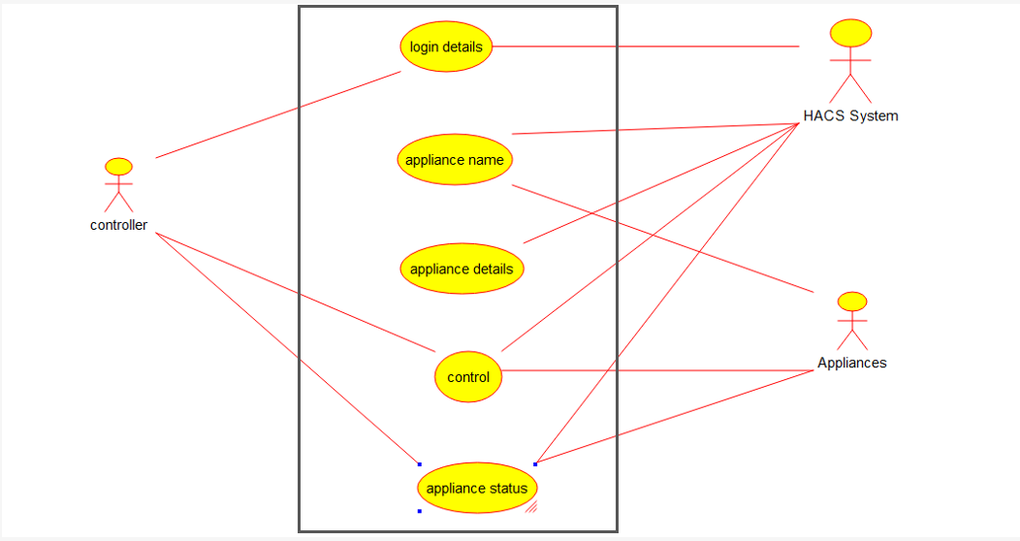

2.CLASS DIAGRAM:

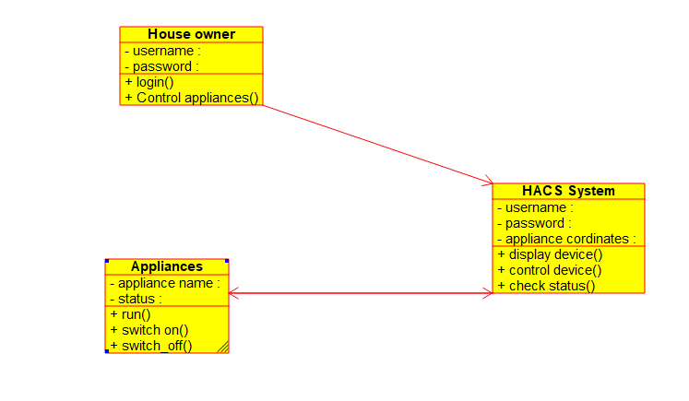

3.SEQUENCE DIAGRAM:

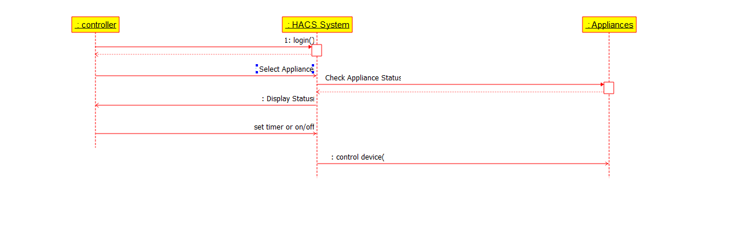

**20.** **Develop a system using UML for Library Management System. It should verify the details of the reader by the central computer. The details regarding the reader will be provided to the central computer through the administrator in the library and the computer will verify the details of the reader and provide approval to the office. Then the books that are needed by the reader will issue from the library to him.**

**AIM:-**

To develop a system using UML for Library Management System.

UML DESIGNS:-

1.PACKAGE DIAGRAM:

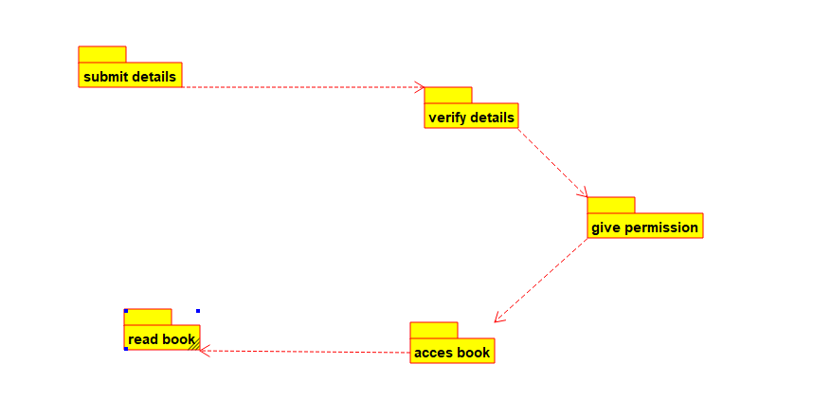

2.COMPONENT:

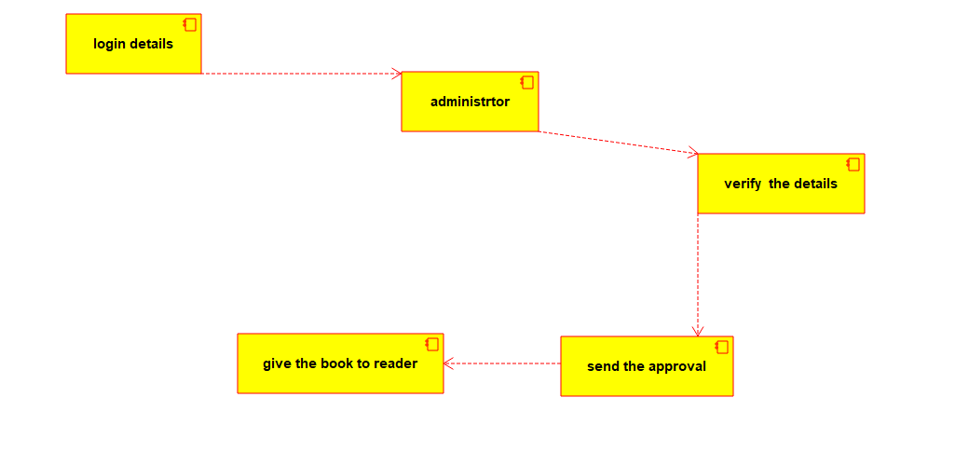

3.ACTIVITY DIAGRAM:

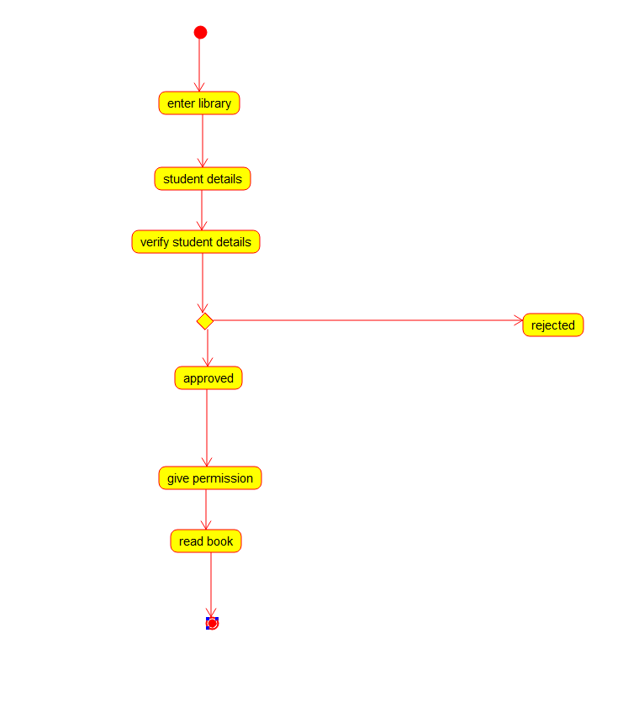

**21. Develop a system using UML for Hospital Management System. The central system should manage patients’ and doctors’ appointments and case details. Also, include medical prescriptions and consultation fee details.**

**AIM:-**

To develop a system using UML for Hospital Management System.

UML DESIGNS:-

1.COLLABORATION:

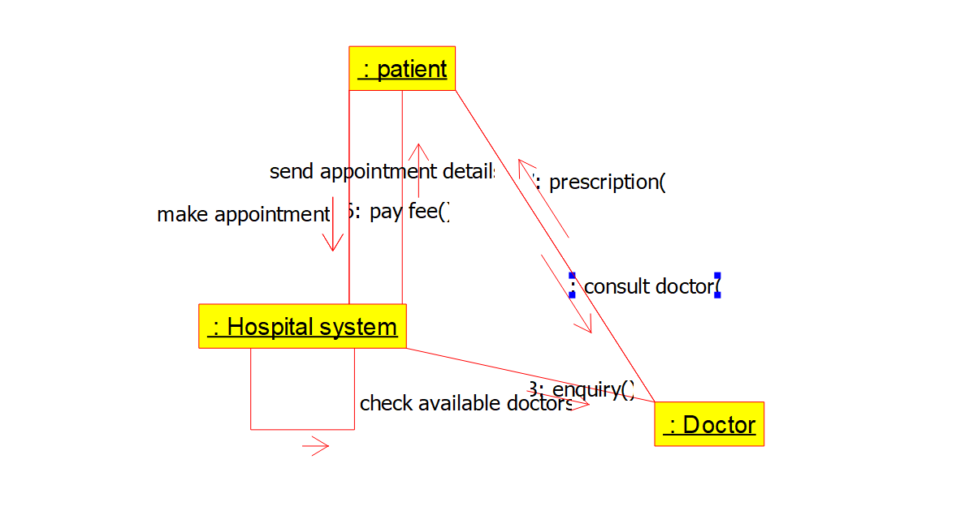

2.DEPLOYMENT DIAGRAM:

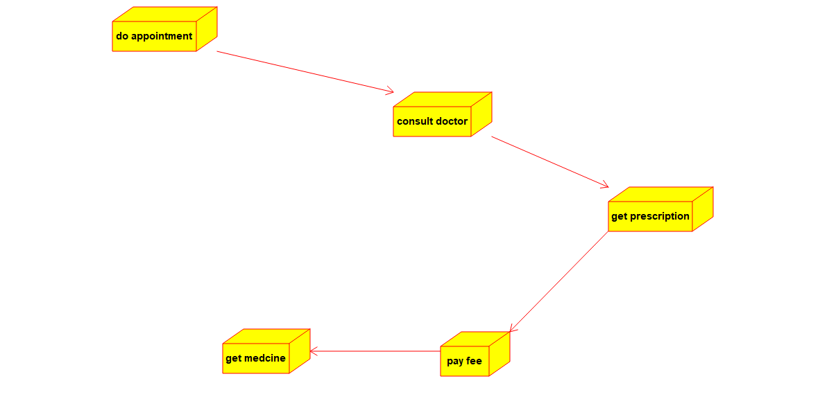

3.STATECHART DIAGRAM:

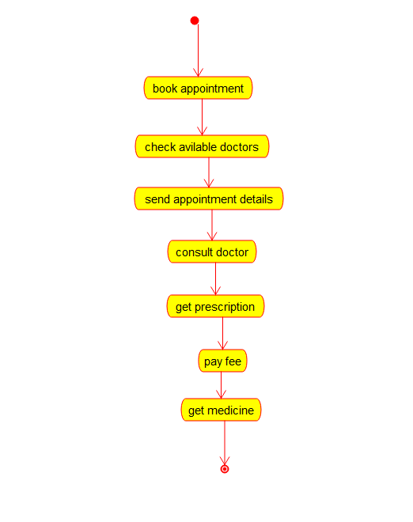

**22. Develop a system using UML for Online Insurance Processing System. The admin can create a category and sub-category, under which a new policy can be added. The user can view and buy the required policies. The system is managed by the Insurance Management System.**

**AIM:-**

To develop a system using UML for Online Insurance Processing System.

UML DESIGNS:-

1.CLASS DIAGRAM:

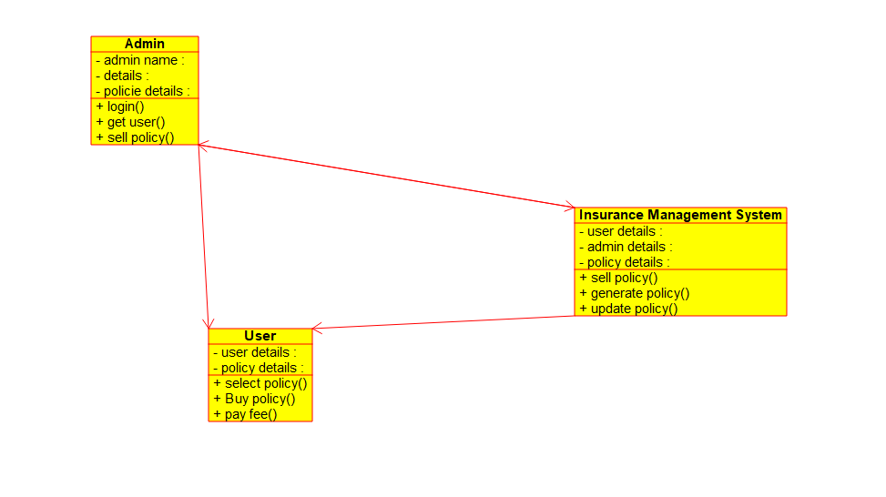

2.DEPLOYMENT:

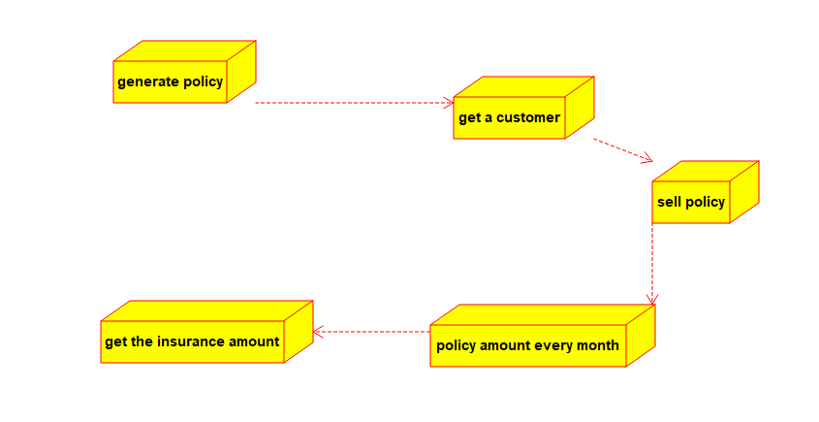

3.ACTIVITY DIAGRAM:

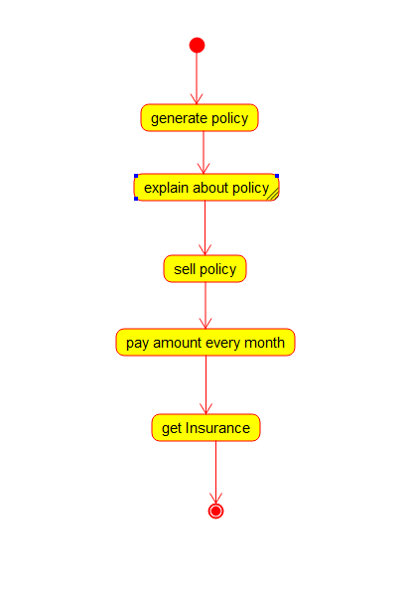

**23.** **Develop a system using UML for Online Shopping System. This system should represent the shopping system as well as its primary users, and roles. The logs of the transactions should be carried out for the shopping. The cart should be maintained before the purchase transaction.**

**AIM:-**

To develop a system using UML for Online Shopping System.

UML DESIGNS:-

1.COMPONENT:

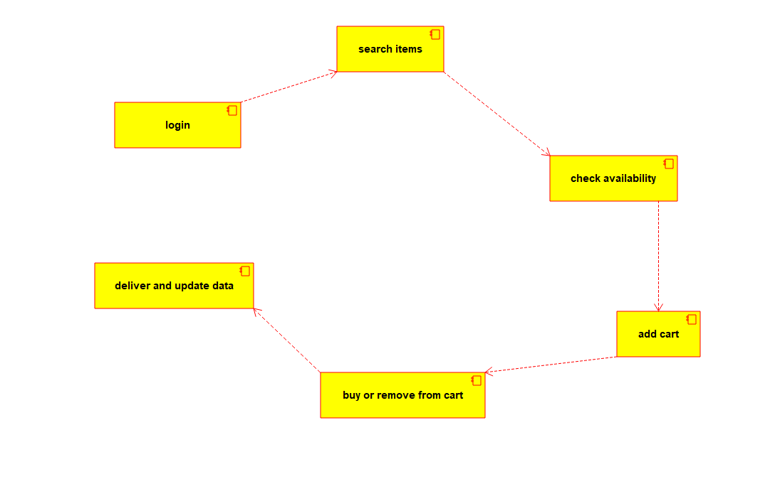

2.USECASE DIAGRAM:

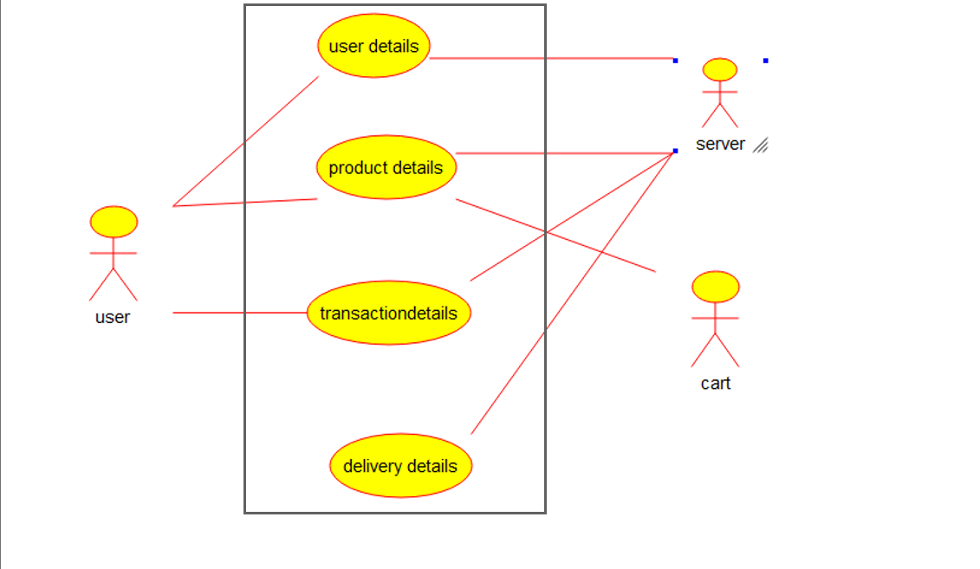

3.PACKAGE DIAGRAM:

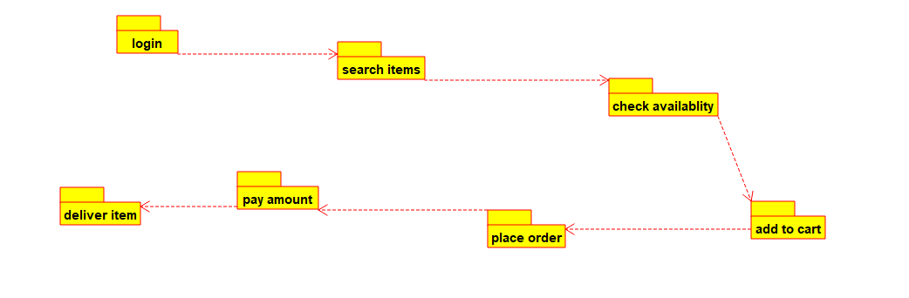

**24.** **Develop a system using UML for Online Stock Market System. This System facilitates its users the trade (i.e. buying and selling) stocks online. It allows clients to keep track of and execute their transactions of the different stocks in their portfolios. The central system should keep track of all the users, who interact with the system.**

**AIM:-**

To develop a system using UML for Online Stock Market System.

UML DESIGNS:-

1.ACTIVITY DIAGRAM:

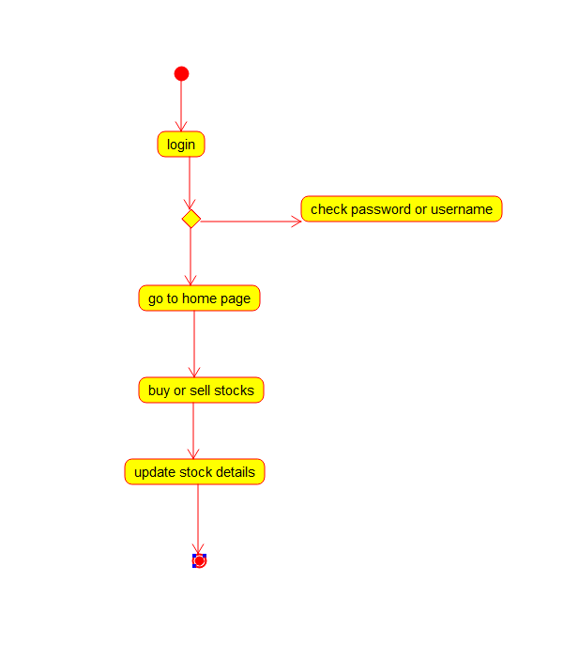

2.USECASE DIAGRAM: 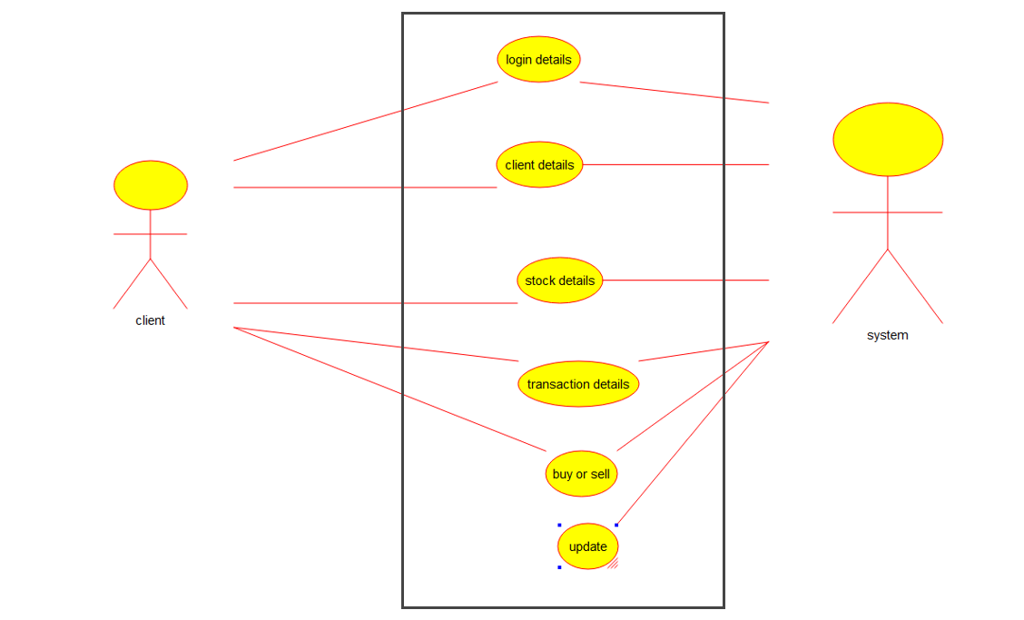

3.CLASS DIAGRAM:

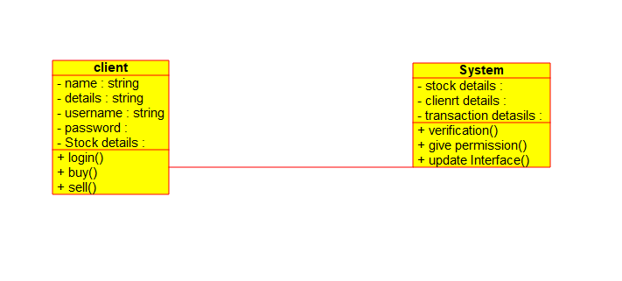

**25.** **Develop a system using UML for Online Voting System. Registration of the new citizen and update can be done in the system. The process of initiating the polling. The voting was done from the citizen’s end and the result publishing should be maintained by the admin.**

**AIM:-**

To develop a system using UML for Online Voting System.

UML DESIGNS:-

1.STATECHART DIAGRAM:

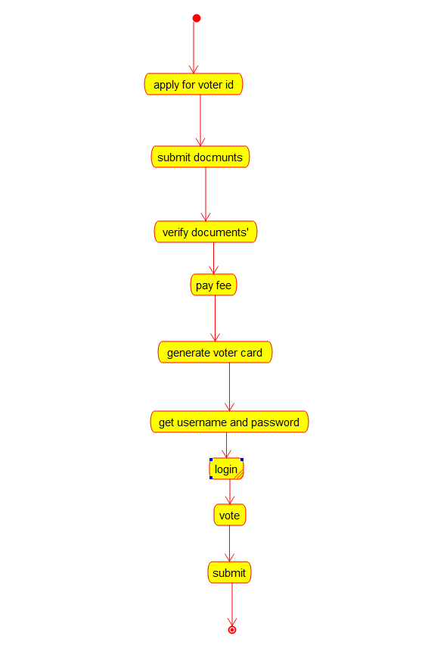

2.COLLABORATION DIAGRAM:

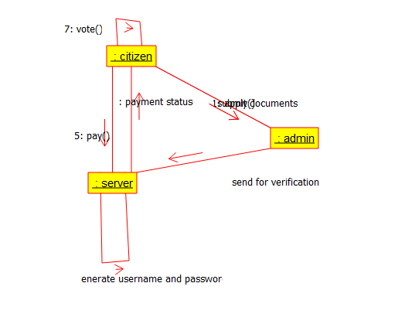

3.SEQUENCE DIAGRAM:

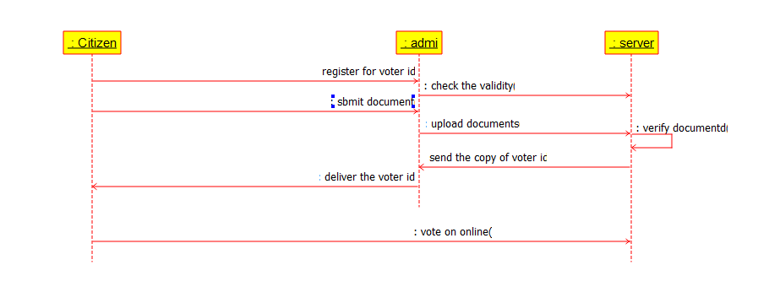

**26. Develop a system using UML for Jewellery Shop Management System. The admin can add new customer detail and update the existing customer’s detail. Whenever a customer made a purchase, Page 4 of 6 it should reflect in the bill details as well as in the customer details. Also, the system should update the stock remained the shop.**

**AIM:-**

To develop a system using UML for Jewellery Shop Management System.

UML DESIGNS:-

1.COMPONENT DIAGRAM:

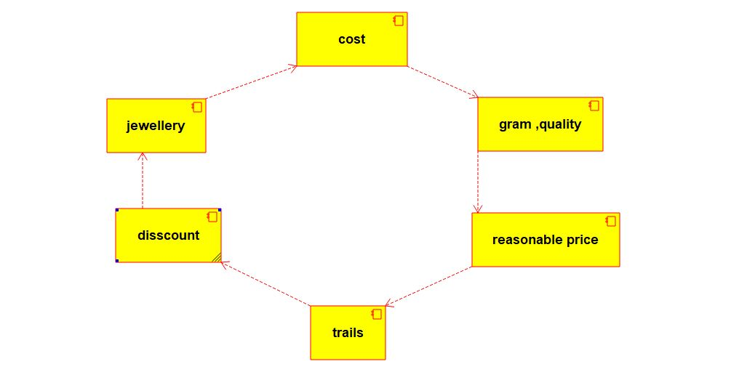

2.SEQUENCE DIAGRAM:

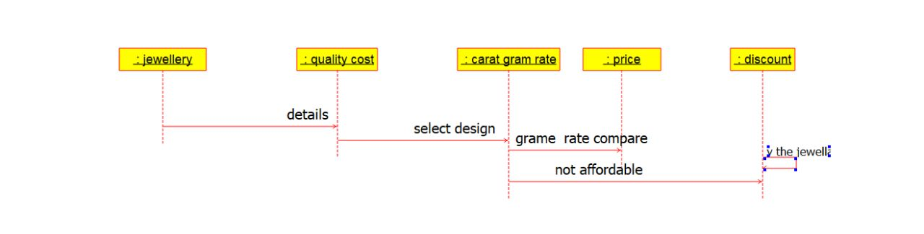

3.USECASE DIAGRAM:

